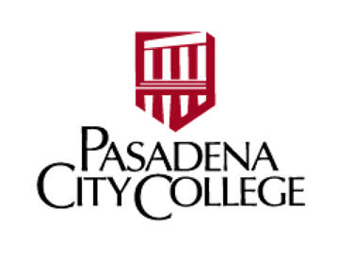

List of Colleges Contacted by Pasadena City College for Collegial Consultation

Santa Monica City College
Citrus College
Los Angeles Trade Technical College
Compton College
Cerritos College
El Camino College

