
Administration of Justice Advisory Committee
Meeting NOTES

Thursday, May 8, 2-24


12:00 – 1:00 PM

Administration of Justice Members
David Barber
Michael Clayton Mag Nicola Kristina Perkins Victoria Perez

AHC
Mitch McCann
John Cecena Kurt Kruse Lainey Campos
Note Taker:
Yvette Dorado
Kurt Kruse welcomed everyone and introduced everyone in attendance
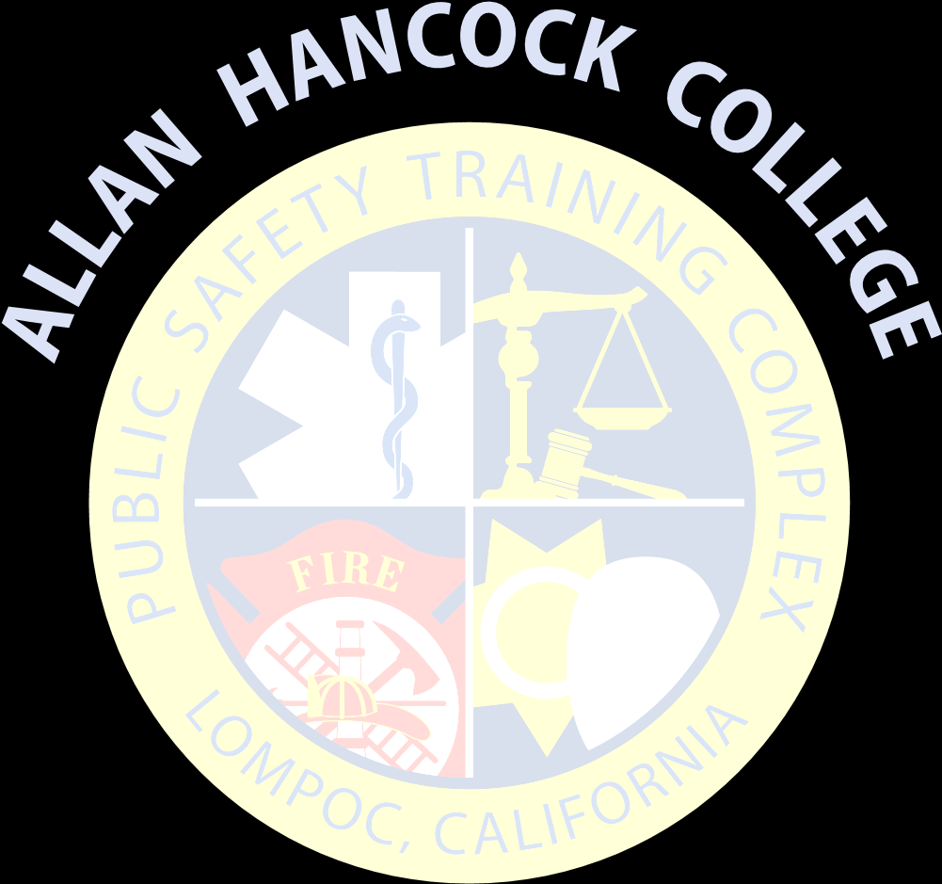
An overview of the Administration of Justice program and the courses offered was discussed.
Program degree and modifications that are currently being added or changed.
- Cooperative Work Experience- thanked the District attorney’s office and public defender’s office for initiating the program
- CTE career academy- Thanked the Santa Maria PD for hosting 23 students for the citizens cademy
- Course offerings
AJ 101-Intro. To Crim Just.
AJ-115-Intro Criminology
AJ 102-Criminal Procedures
AJ 103-Concepts of Criminal Law AJ 104-Legal Aspects of Evidence AJ 105-Community Relations
*AJ 106-Patrol Procedures* AJ 120-Juvenile Law
AJ 130-Intro. To Corrections
*AJ 149-Cooperative Work Experience (WEE)*
AJ 150-Intro. To Forensics

Kurt asked the committee if there were any courses that they needed to add or delete. The committee thought that the offerings were good and didn’t need change. We have a lot of cool supplies to give the students a good hand on experience.
Discussed the upcoming Cybersecurity courses.

  - Local Degree-AJ 149, AJ 106
2. Roundtable
Dave – feedback he gets from students is they’re happy.
DDA – Well rounded offerings – agreed with everything offering.
Tina- Thanked the new courses, a new course to the class listing. Work experience -

