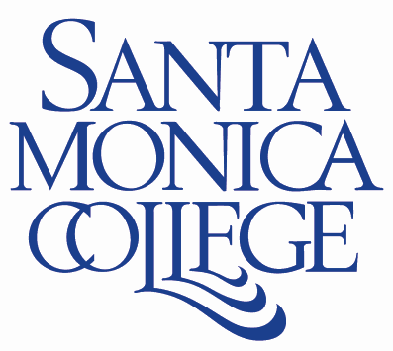

1900 Pico Boulevard, Santa Monica, CA, 90405
310.434.4611

SMM/SST INDUSTRY ADVISORY BOARD MEETING
MINUTES
Wednesday, November 15, 2023 2pm
Zoom Meeting
(Information items are listed numerically; action items are listed alphabetically)

Industry Advisory Board Members Present:
Stephanie Barger – USGBC-LA
Ivory Chambeshi – Urban Rising Group
Tom Fleming – City of Santa Monica
Judi Gregory – Go2Zero
Amy Hammes – City of Burbank
Jon Huls – Sustainable Environmental Management Company
Laurel Joe – BlueSphere Partners
Mike Learakos – Abound Food Care
Simone Paz – Museum of Modern Art (MOCA)
Ivanni Perez – Sustainable Works
Ursula Schmidt – City of Pasadena
Alex Han, Athens Services
Judy Ware,

Industry Advisory Board Members Absent:
Andrea Chase – Arbonne
Rob Edelstein – Bottom Line Utility Solutions
Natalie Flores – Nourish LA
Artealia Gilliard- Ford Motor Co
Ben Kay - Santa Monica High School, Adjunct Professor Life Sciences (SMC)
Karen Levano – Athens Services
Mike Lewis – Goldman Sachs
Lauren Nevitt – SunRun
Eric Newton – Universal Wase Systems

Interested Parties Present:
Victoria Charles, Assistant Professor RRM & SST (SMC)
Gillian Grebler, Adjunct Professor Anthropology & SST (SMC)
Ferris Kawar, Sustainability Project Manager (SMC)
Eric Minzenberg, Chair Earth Science Department, Professor Anthropology (SMC)
Kim O’Cain, Adjunct Professor SST (SMC)
Samuel Sasu, Adjunct Professor RRM (SMC)
Angela Vincent, Adjunct Professor RRM (SMC)
Scott Silverman, Dean Noncredit and External Programs (SMC)
Walter Butler, Director of Library Services (SMC)

- Call to Order and Approval of Minutes
The meeting was called to order at 2:10 pm
Motion to approve the Agenda
Motion made by: Ivory Chambeshi, Seconded by: Judi Gregory
The motion passed unanimously

- Public Comments
None

- Announcements/Information Items

- USGBC True Advisor Certificates – To date 18 (or 20) student passed and are accredited as True Advisors
- New Adjunct Faculty hire for RRM 3- Angela Vincent
- Certificates awarded in the RRM Program
- ZTC/OER Grant – Walter Butler, SMC’s Director of Library Services, reported on receipt of 2023-2026 OER/ZTC Acceleration Grant of which the RRM program is one of the recipients. SMC received the maximum grant of $200,000. The grant provides for Professional Development, Marketing and Course Conversions to OER/ZTC
- Action Items
- RRM Program Name Change to ‘Sustainable Materials Management,’ SMM
Motion made by: Ivory Chambeshi
Seconded by: Stephanie Barger
The motion passed unanimously

- RRM Department Certificate Name Change to ‘SMM General Certificate’ 12 units
Motion made by: Mike Learakos
Seconded by: Laurel Joe
The motion passed unanimously

- RRM State Certificate of Achievement Name Change to ‘SMM Advanced Certificate of Achievement’ 18 units
Motion made by: Laurel Joe
Seconded by: Ivory Chambeshi
The motion passed unanimously

- Name change of RRM AS Degree to ‘SMM AS Degree’
Motion made by: Laurel Joe
Seconded by: Jon Huls
The motion passed unanimously

- Revision of elective classes for SMM (currently known as RRM) Advanced Certificate of Achievement
Motion made by: Jon Huls
Seconded by: Laurel Joe
The motion passed unanimously

- Discussion
- Advisory Board Members announced upcoming programs and new developments in their respective organizations and businesses
- Ivory Chambeshi and Ursula Schmidt offered to join the SMC Cool Sustainability Careers Panel on December 6, 2023
- Recommendation to integrate Excel and other data training into programs
- Importance of promoting programs emphasized
- Suggestion for mentorship and one-on-one meetings between students and industry professionals/advisory board members
- Discussion of the paths students have followed from noncredit to credit to transfer to jobs. Examples given
- Agreed on need to track students who receive certificates

- Adjournment
The meeting was adjourned at 3:41 pm

